VECTORLESS RAG

Retrieval-Augmented Generation (RAG) has become a widely adopted architecture for building AI applications that combine Large Language Models (LLMs) with external knowledge sources.
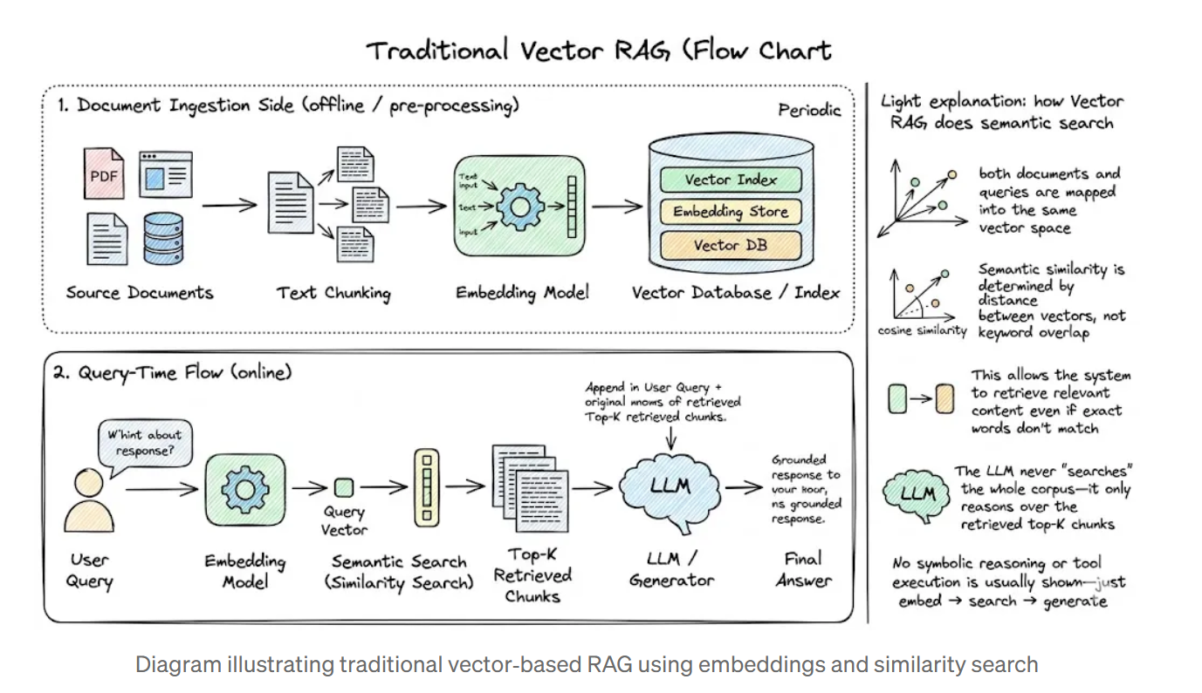
Traditional RAG pipelines rely heavily on vector embeddings and similarity search to retrieve relevant documents. While this works well for many scenarios, it introduces challenges such as:
- Requires chunking documents into small segments
- Important context can be split across chunks
- Embedding generation and vector databases add infrastructure complexity
A new paradigm called Vectorless Reasoning-Based RAG is emerging to address these challenges.
One framework enabling this approach is PageIndex, an open-source document indexing system that organizes documents into a hierarchical tree structure and allows Large Language Models (LLMs) to perform reasoning-based retrieval over that structure.
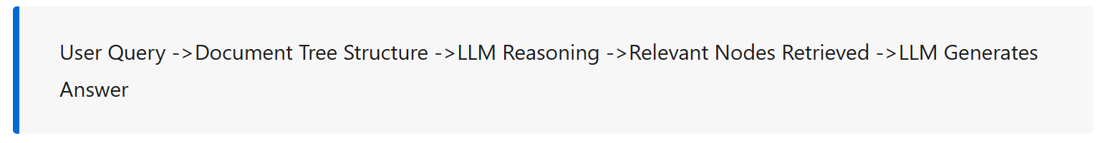
This makes it particularly effective for unstructured corpora such as research papers, conversational logs, or diverse knowledge bases where keyword search would fail.
Vectorless RAG is an retrieval-augmented generation approach that retrieves relevant information from documents without relying on vector embeddings. Instead, it organizes content into indexed pages or structured sections, allowing fast keyword-based retrieval before passing the selected context to a language model for generating accurate responses.
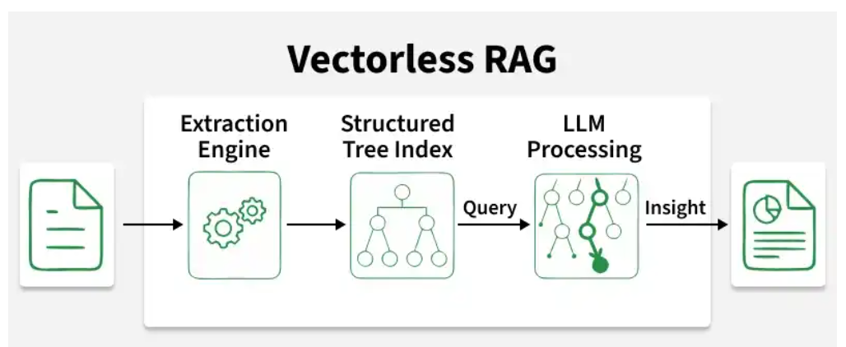

Vectorless RAG is a retrieval approach that removes the entire embedding and vector similarity layer from the RAG pipeline. No embedding model. No vector database. No cosine similarity scores. No top-k nearest-neighbor search.
Instead, it structures documents as hierarchical trees and uses an LLM to reason about where the answer is located — the same way a human expert would navigate a complex document. A human reading a 200-page financial report doesn’t scan every paragraph for the one most statistically similar to their question. They check the table of contents, identify the relevant section, flip to the right page, and read it. Vectorless RAG replicates that process algorithmically.
When to Use Vectorless RAG
Vectorless RAG works best when:
- Data is structured or semi-structured
- Documents have clear metadata
- Knowledge sources are well organized
- Queries require reasoning rather than semantic similarity
The primary implementation is PageIndex, an open-source framework published in September 2025 by VectifyAI. The core insight is borrowed from AlphaGo: instead of searching exhaustively through all possible positions, use a learned strategy to navigate the search space intelligently. Applied to documents: instead of measuring similarity to every chunk, reason about the document’s structure and navigate directly to the relevant section.
PageIndex defines three properties that distinguish it from traditional RAG. No vector database — document structure and LLM reasoning replace similarity search entirely. No chunking — documents are organized into natural sections that reflect their actual structure, not arbitrary token windows. Human-like retrieval — the system simulates how a human expert navigates a book: check the table of contents, find the relevant section, read it.
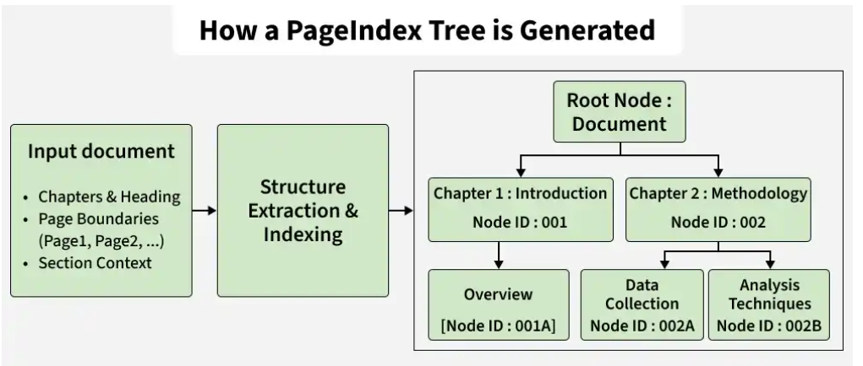
After splitting the document, a tree-like structure is created to organize it properly.
- The root represents the entire document
- Middle nodes represent sections and subsections
- Final nodes represent individual pages
This structure makes navigation easy and systematic.
PageIndex is a reasoning-based, vectorless RAG framework that performs retrieval in two steps:
- Generate a tree structure index of documents
- Perform reasoning-based retrieval through tree search
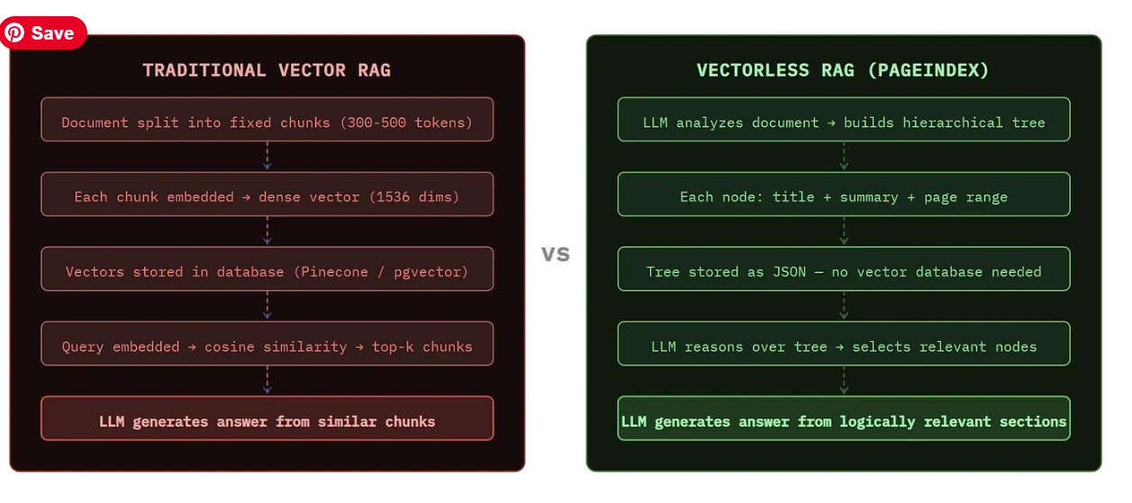
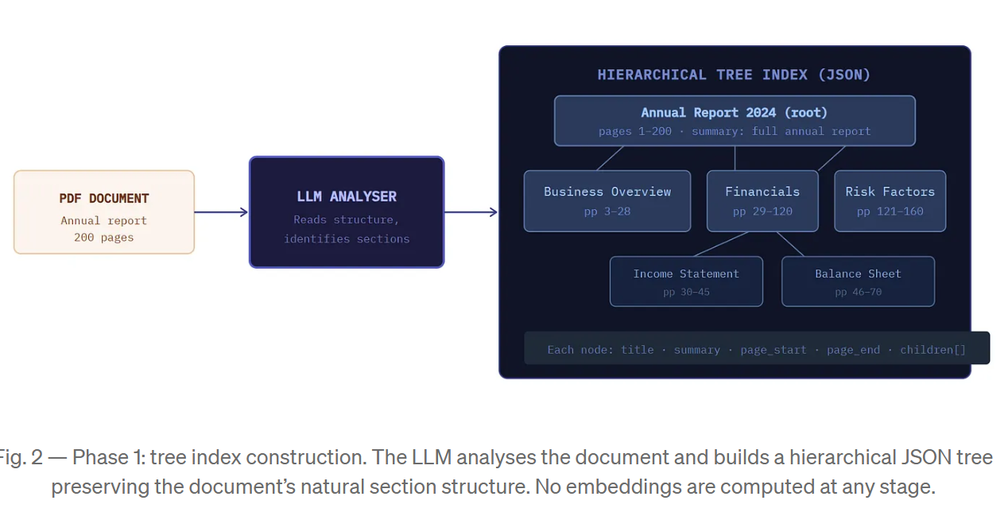
When a query arrives, PageIndex passes the entire tree structure (just titles and summaries — a small context) to an LLM and asks it to reason about which nodes are most likely to contain the answer. The LLM reads the tree, applies domain reasoning, and returns a ranked list of node IDs to retrieve the full content from.
Use vector RAG when:
You need sub-second response times at high query volume. You have a large corpus of many short, diverse, loosely structured documents. Your documents are unstructured, conversational, or narrative prose where section hierarchy carries no special meaning. You’re building consumer-facing products where 85–90% accuracy is acceptable. You need to search across thousands of documents to find the relevant one before drilling in.
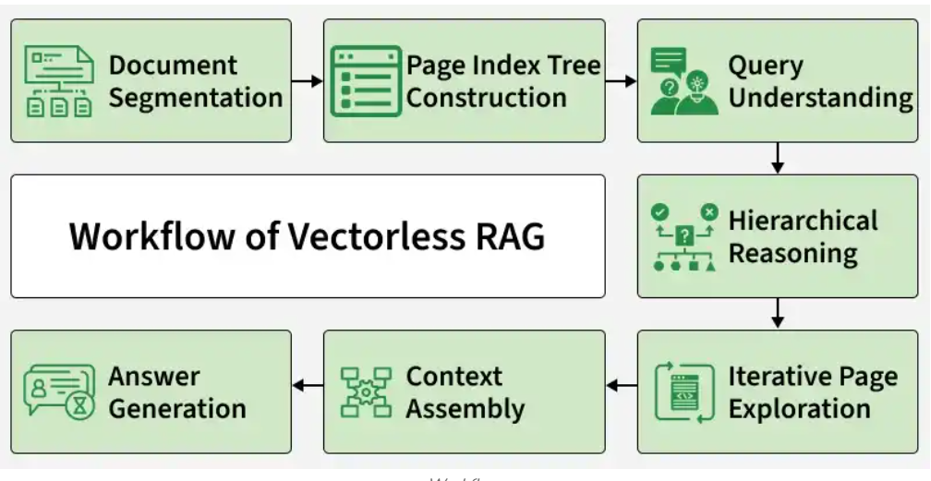
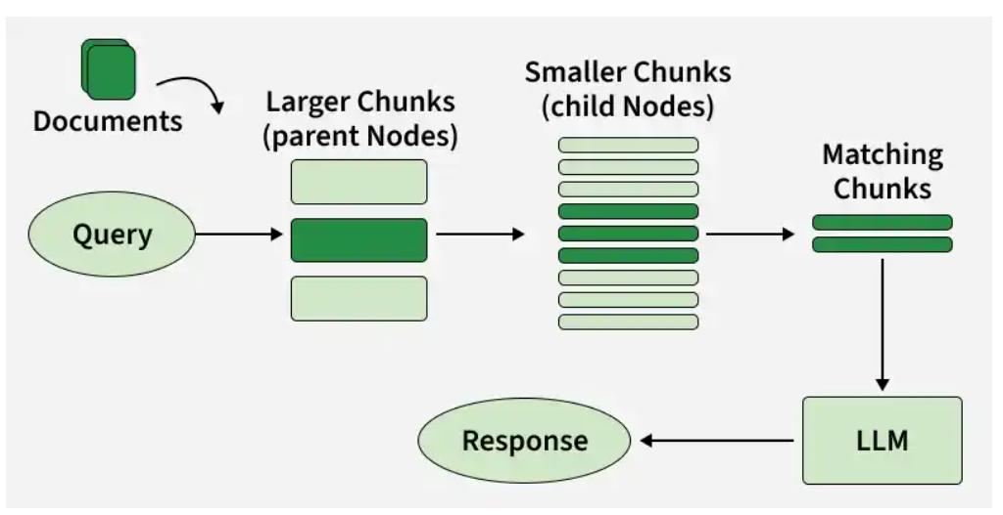
Implementation
Step 1: Install Required Library
Install the necessary libraries for hierarchical document indexing (pageindex) and for integrating the Gemini LLM using LangChain.
Step 2: Import Required Libraries
Now we import all necessary Python modules for document handling, API communication and async processing.
- os, json, requests: File handling and PDF download
- asyncio, time: Handle asynchronous processing and polling
- PageIndexClient: Core client for interacting with PageIndex
- pageindex.utils: Utility functions like printing document tree
Step 3: Initialize PageIndex Client
- Here we configure the API key and initialize the PageIndex client.

Step 4: Download the PDF Document
- Here we download a research paper from ArXiv and save it locally.

Step 5: Submit Document to PageIndex
- Now we upload the PDF to PageIndex for hierarchical indexing.
Step 6: Indexing
Since indexing takes time, we poll the system until the document is ready.
- Use is_retrieval_ready() to check indexing status.
- Implement retry logic with timeout handling.
- Once ready, fetch and print the document tree.

Step 7: Initialize the LLM
- Next, we configure the Large Language Model that will generate answers using retrieved context.
Step 8: Define Retrieval Function (Vectorless Retrieval)
This function sends the user’s question to PageIndex, waits until the system finds the most relevant sections in the document and then extracts the useful text content for answer generation.
- First, it submits the query to PageIndex using submit_query() and receives a retrieval_id.
- Then, it continuously checks (polls) the retrieval status until it is completed.
- Finally, it collects the relevant text content from the top matching nodes and returns them as context.
Step 9: Build Vectorless RAG Pipeline
This function combines retrieved context and sends it to the LLM.
- Retrieve structured content from PageIndex.
- Combine context into a single prompt.
- Ask the LLM to answer strictly from retrieved context.

Step 10: Run Query and Generate Final Answer
- Here we provide a question and generate the answer using Vectorless RAG.
Limitations
- Depends heavily on the quality of document structure as poor headings reduce effectiveness
- Relies on the reasoning ability of the LLM, which may sometimes choose the wrong branch
- Can be slower due to step-by-step navigation
- Less effective for searching across many unrelated documents
- Performance may drop if the document is unstructured or poorly organized
MERITS
- Eliminates Embeddings and Vector Databases: Uses document structure and LLM-guided reasoning instead of dense similarity search.
- Avoids Artificial Chunking: Preserves natural document sections such as pages and headings, maintaining contextual continuity and logical structure.
- Human-like Retrieval: Traverses a tree-structured index step by step, similar to how experts analyze and locate relevant information.
- Transparent Retrieval Process: Produces traceable and interpretable retrieval decisions rather than relying on approximate semantic matching.
